**Preventing, Intervening, and Recovering from**

# SCHOOL SHOOTINGS

**and Other Traumatic Events**

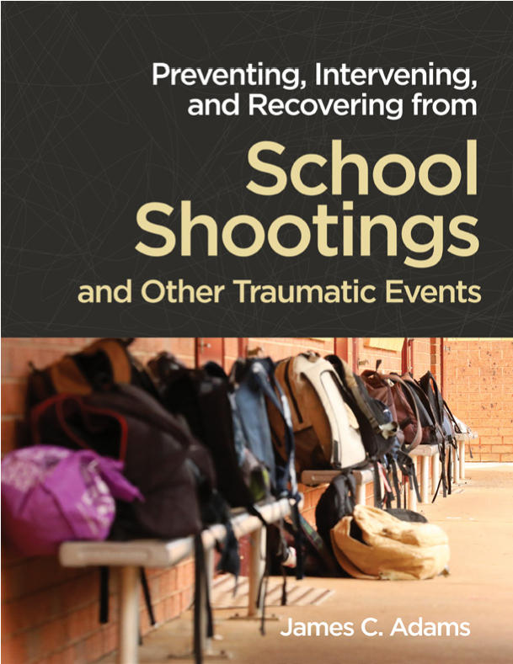

SCOPE AND SEQUENCE

**What Is *Preventing, Intervening, and Recovering from School Shootings and Other Traumatic Events*?**

Based on research studies and the emerging best practices utilized at dozens of actual shooting sites across the country, this manual provides a practical guide for schools to develop a comprehensive prevention and crisis response to a school or community shooting. The blueprint contained within this manual will be invaluable when responding to a traumatic event of any magnitude. *School Shootings* comprises two key components:

* **Detailed options:** Many schools already have prevention and/or crisis response plans, but this manual helps schools review their current plans against potential alternatives and additional detailed options. The goal is not to re-create a plan from scratch, but to improve on that plan based on the experience of schools that have been through an actual school shooting.
* **Practical tools:** Included on this manual’s flash drive are specific electronic forms for every aspect of a school’s prevention and/or crisis response plan. The forms include planning guides, immediate response reminders, information for family members, and long-term planning goals, as well as strategies on how to create task forces.

**Why Is It Important to Address School Shootings and Other Traumatic Events?**

While the number of deaths by school-associated homicides varies from year to year, the number of multiple-victim school-associated incident rates increased significantly from July 2009 to June 2018.1 The time between those shooting incidents has diminished, with tragedies happening more frequently, as the average number of days between shootings has dropped over time. According to a report compiled by the Colorado Public Radio station KUNC, “From 1999 to 2014, the average number of days between shootings was 124 days. From 2015 to 2018, the average was 77 days.”2 These are trends we need to track and reverse to keep our children safe.

Additionally, many individuals, when talking about school shootings and victims of school shootings, only think of those assaulted during school hours, in school facilities. Often victims are injured or killed on the way to or from a school building or at a schoolsponsored function. The other distinction in tracking school shootings is mass shootings versus single-victim shootings. Between 1994 and 2016, 90 percent of school shootings involved a single victim. Mass school shootings of four or more victims accounted for 18.6 percent of homicide victims during the same time period.3

Schools are still a relatively safe environment for our children, but none of these statistics convey the long-term impact on lives and even deaths by suicide or other means that happen as an after effect of these few school shootings. To understand the true tragedy of a school shooting, that research has yet to be done. And while it is easy to recite seemingly small numbers of school-related deaths, every loss is an inestimable tragedy to a victim’s family, friends, and community.

**What Are the Goals of *School Shootings*?**

The goals of this manual are to

* help schools create a comprehensive prevention plan and crisis response plan
* reduce trauma after a fatal event
* help schools and communities develop a long-term recovery plan

**Who Is the Intended Audience?**

Planning for and responding to trauma requires a multidimensional approach. The more individuals and community groups included in the initial planning process, the better the response, and the better the health and well-being of students, staff, and community alike. Consider involving the following personnel and organizations when implementing the recommendations of *School Shootings*:

* school staff, leadership, and partners
* mental health professionals, agencies, and organizations
* local, state, and national government officials
* first responders and law enforcement agencies
* community and government emergency planning organizations
* foundations and relief agencies

**Is *School Shootings* Research Informed?**

This manual summarizes some of the best research available on prevention, intervention, response, and recovery, with examples of emerging best practices established through actual shooting recovery sites. While many treatment and prevention strategies have been researched and tested using the most scientific processes available, establishing “best practice” recognition for many of the insights offered in *School Shootings* is difficult based on the low incident rate of mass school shootings in the United States. The gold standard of having a comparative control group to help establish best practice isn’t practical in these situations. Nevertheless, it is clear what has helped primary and secondary victims address their trauma and recover their lives over time; those emerging best practices are shared in *School Shootings*.

This manual also provides unique insights into what specific interventions have worked and what interventions haven’t been as effective or still need more development. *School Shootings* summarizes the similarities in responses between different shooting events that have the potential to be considered emerging best practices. The manual explores many individual examples of how communities worked together to restore their school and bring back a sense of safety and hope.

*School Shootings* also uses research to describe the physical and mental response to trauma, shedding light on why particular interventions may be instrumental in recovery. What happens to the brain during trauma and what do we know about how it may heal? According to behavioral therapists and psychiatrists, medication and different types of therapeutic interventions may have a major impact on the quality of life and healing process of those impacted by trauma.

***School Shooting* Components**

The following is a brief description of each component of the *School Shootings* offerings.

## Manual

The 168-page manual provides practical guidance for developing or revising a prevention plan and crisis response to a school or community shooting or other traumatic event to be as comprehensive as possible. The manual provides a thorough, hands-on approach to critically timed needs, with specific information on how to respond in the minutes, hours, days, weeks, months, and even years after a school tragedy. These are not broad guidelines but well-defined protocols based on what has worked and what may work for your school. The manual is divided into four parts:

**Part 1: Understanding School Shootings**

Introduction to School Shootings Overview of This Manual

**Part 2: Prevention and Early Intervention**

Prevention Using Safety Precautions

Prevention within Schools and Communities

**Part 3: Crisis Planning and Response**

Crisis Preparations and the First Minutes After

The First Hours After

The First Days After

The First Weeks, Months, and Years After

**Part 4: Recovery**

Long-Term Community Recovery

## Planning Forms

Included with the manual are more than 70 specific forms for every aspect of a school’s crisis response and prevention planning. The forms provide planning guides, immediate response reminders, parent/caregiver information, and guidance for setting long-term goals. Below are some examples of the forms included on the manual’s flash drive:

* Prevention Task Force, Initial Meeting Agenda
* Prevention Program Resources Survey
* Active Shooter Training Review
* Mental Health Early Assessment and Intervention
* Preparation for Crisis Response: The School Crisis Team, Planning for the First Minutes
* Preparation for Crisis Response: The First Responder Team
* Crisis Response, The First Minutes: School Shooting or Traumatic Event Checklist
* Crisis Response, The First Hours: The Media Team, First Press Conference Checklist
* Crisis Response, The First Hours: The Mental Health Trauma Team, Crisis Response Checklist
* Crisis Response, The First Days: The School Crisis Team, First Day of School Checklist
* Long-Term Recovery: School and Community Recovery Collaborative

## PowerPoint Presentation

Hosting an information session is a great way to build the multidisciplinary approach and the school and community support needed to build comprehensive prevention and crisis response plans. The 45-slide PowerPoint presentation provides an overview of the *School Shootings* model and increases school and community understanding of why prevention and crisis response planning are critical components to student safety and well-being.

**About the Author**

James “Jim” Adams is the President of Rise 4 Solutions, a company dedicated to reducing violence and specializing in prevention and recovery from school shootings and other traumatic events. A researcher, lecturer, and consultant on trauma preparedness and response, Jim is an advocate for the prevention of school and community violence.

Jim has been nationally recognized for his development of a unique short- and long-term mental health recovery plan for Chardon, Ohio, and the surrounding community after a mass shooting of six students on February 27, 2012. His community based minute-by-minute trauma-informed recovery plan, implementation model, and subsequent research findings on school and community trauma response after a mass shooting have been used in schools and communities around the country.

**Notes**

1. Centers for Disease Control and Prevention, “School-Associated Violent Death Study: Major Findings,” October 24, 2019, https://www.cdc.gov/violenceprevention/ youthviolence/schoolviolence/SAVD.html.
2. Luis Melgar, “Are School Shootings Becoming More Frequent? We Ran the Numbers,” Guns and America, posted by KUNC, Greeley, Colorado, May 17, 2019, https://www.kunc.org/2019-05-17/are-school-shootings-becoming-more-frequent-weran-the-numbers.
3. CDC, “School-Associated Violent Death Study.”